Cotswold 113 2020 – Race Information Sheet
Race date – 20th Sept 2020

Dear Competitor

Please find as follows the full race information pack for competitors of the Cotswold 113 Middle Distance Triathlon on Sept 20th 2020

Within this race pack we will cover the following;
1. Location & Parking access
2. Registration schedule & details/requirements
3. Race day schedule Inc. Start times and waves
4. Race information
5. Rules and regulations
6. Spectators information and guidelines
7. Points of contact
8. Age groups and prize allocation
9. First Aid & Emergency cover
10. Nutrition and Aid Stations
11. Post race Massage and Recovery Area
12. Race Photography
13. Marshal Support
14. Relay team specific rules
15. Covid-19 Specific Rules and changes

- Location and Parking access

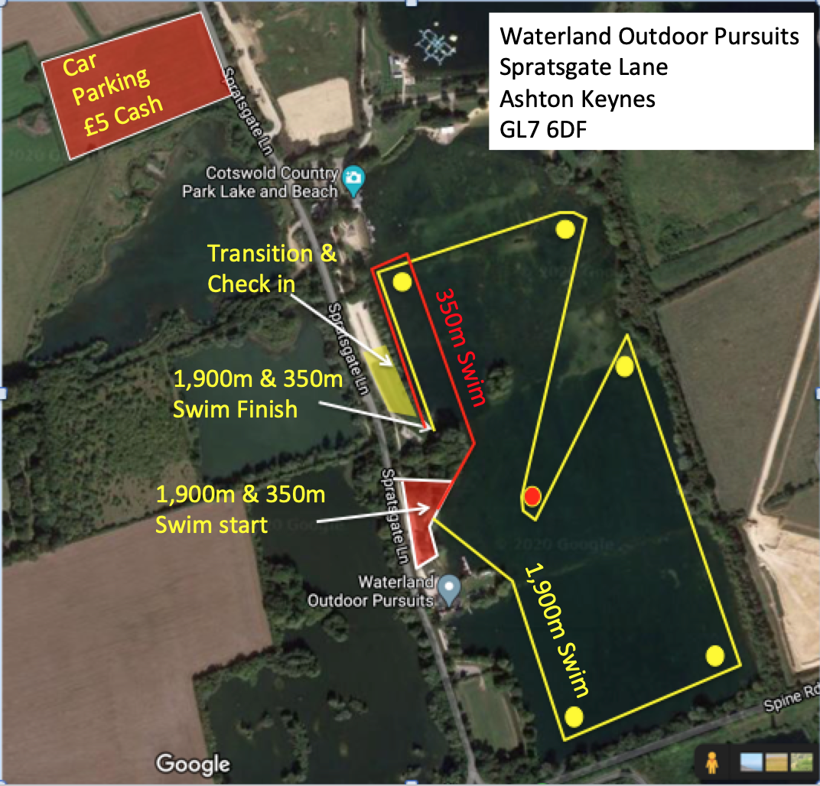

The race will start and finish at Waterland Outdoor pursuits based on Spratsgate lane, Ashton Keynes, Gloucestershire. The postal code for this location is GL7 6DF and it’s located just off the spine road from the A417/9

Parking access on race day will be at the above marked Parking Field, which is accessible from both directions on Spratsgate Lane
The area will be open on race morning from 04:45
Parking is £5 Cash only on the gate

For those of you camping, then the Go-by-cycle field is located on the end of Spratsgate lane ;

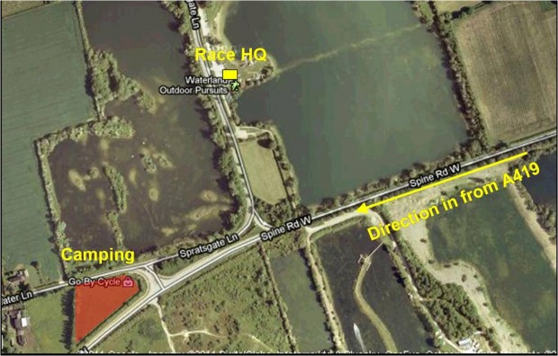

- Registration schedule & details/requirements
You will receive your race bib and bike sticker in the post before race day.
When you arrive at Transition on race morning, you will be checked into transition with your race bib, and in your position in Transition will be your timing chip and swim hat.
If you are a BTF member, you will need to bring with you a copy of your 2020 membership card. This can be in either physical form, as a picture on your phone or as a photocopy.
If you are not a BTF member, you will need a form of photo ID (on phone or photocopy is fine) and £5 cash for a day license.

3. Race day schedule & Start time

04:45 Car Park opens
05:00 Transition opens for bike racking
07:15 transition Closes
07:00 Race starts in 6 rolling start waves.
Each wave will have a 15minute window in which to cross the start line, and will be set off at 10second intervals.
07:00-07:15 Wave 1
07:15-07:30 Wave 2
07:30-07:45 Wave 3
07:45-08:00 Wave 4
08:00-08:15 Wave 5
08:15-08:30 Wave 6
You can choose either the full 1,900m Swim or a Shorter 350m Swim at this point, and we’ll have two chutes, one of each distance. You may also choose to start on the bike and skip the Swim entirely. Please let a member of the transition team know this, and they will let you into transition to start on your bike when the bike course is open from around 07:30 (you must still rack your bike before 7:15am)
If you are starting on the 350m Swim course, you will not be able to start until 07:30, but you can head off in any wave after that regardless of which wave you’ve been allocated on the start list

Please ensure when entering transition, that your bike is labeled up with the supplied race number bike sticker and that you are wearing your helmet fastened so that the safety marshals can check it. (Only competitors with a race number will be allowed to enter transition)
There are 45 x portaloos just past the registration tent near to the race start area.
There will be 2 x portaloos in transition, but these will not be open until the race starts, and will be for use during the race if you need to go in transition
The transition will close for all competitors at 07:15 and must be cleared*
*relay bike members may remain

When collecting your bike from transition, please provide the marshal with your race number so that they can match it to your bike label. Without this, you will not be allowed to remove a bike from transition

4. Race Information

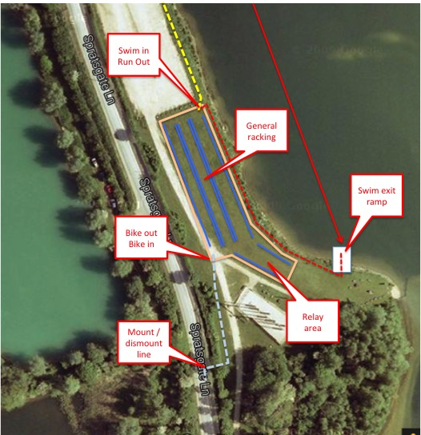

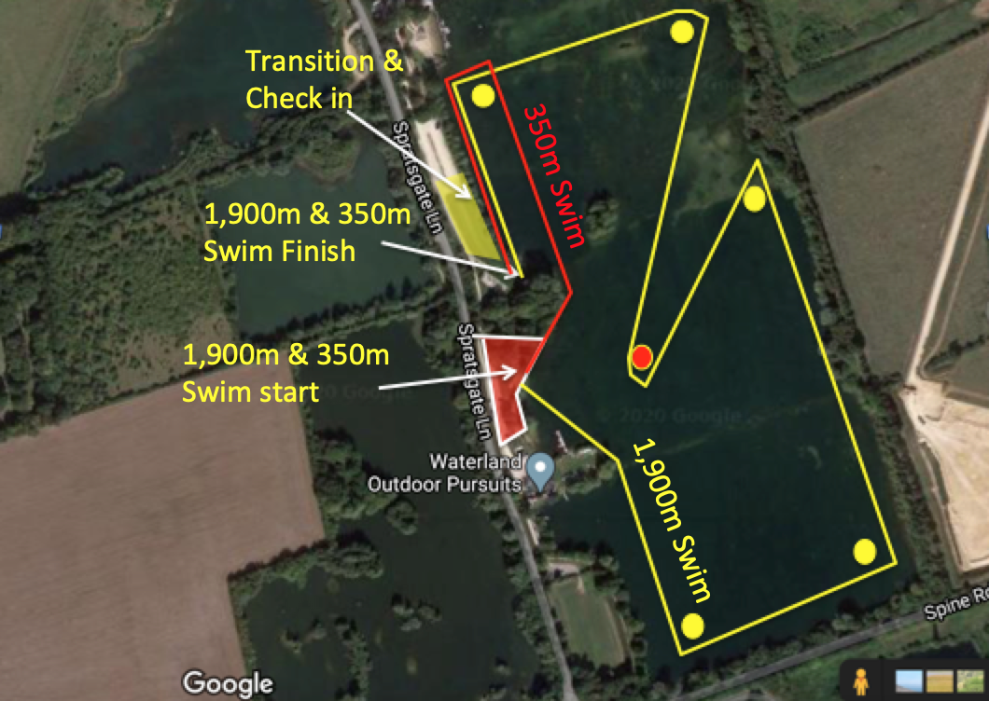

When you arrive at the Swim start area, you will see two chutes. One marked for a 350m Swim and one marked for a 1,900m Swim. Our chip timing system will record your start for either distance, and we will record on the results accordingly, so you can choose either distance on race morning.
The 1,900m Swim is as per the yellow line on the above map.
The 350m Swim is as per the Red lines above, and is a straight left around the headland and out to the final buoy before coming back into the Swim exit.
The starts will be rolling, and competitors will be separated by 5-second intervals. Each wave has a 15minute window in which to start, and there is no specific order within this wave
Start lists with wave times can be found at :
https://www.113events.com/cotswold-113/start-list/

The bike course is split into three sections:

Out section
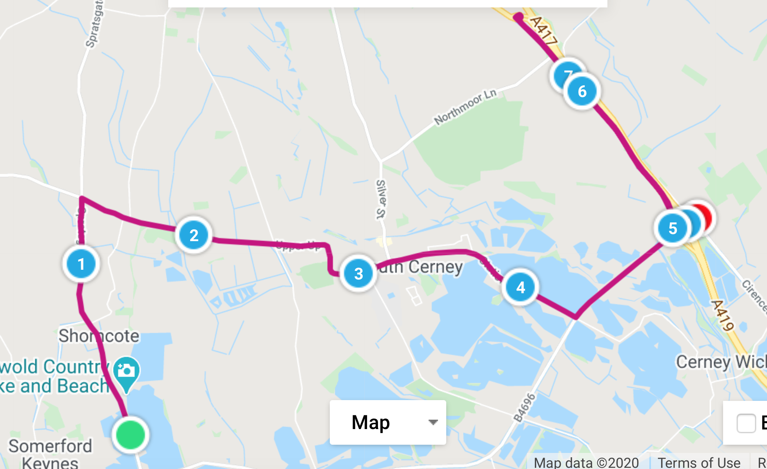

Lap Section (2 Laps)
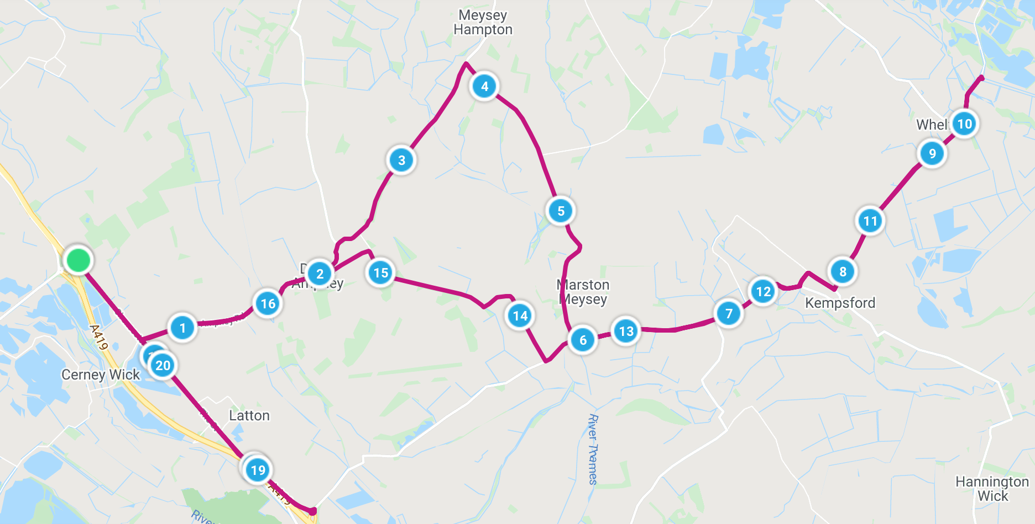

Return Section
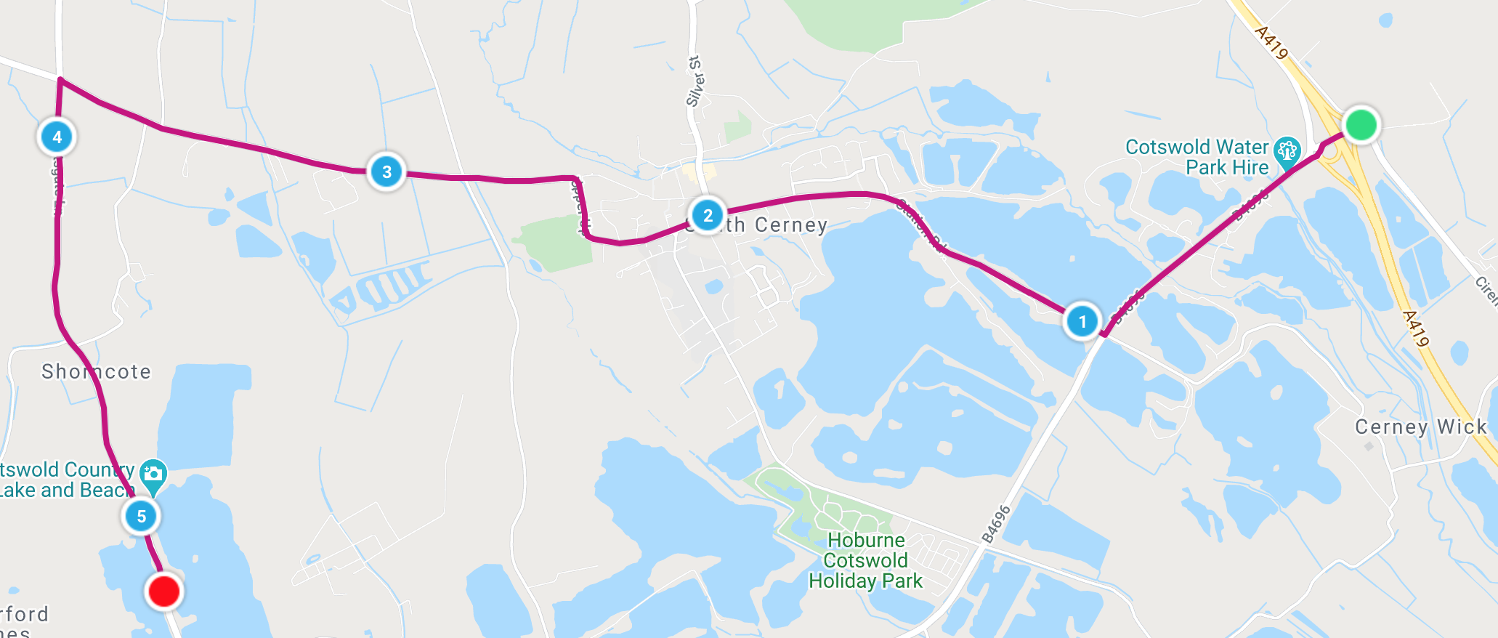

Larger details and interactive links to these sections are available at :
https://www.113events.com/cotswold-113/course/

You will take the ‘Out Section’ to the Latton Road Roundabouts where you will commence two laps of the ‘Lap Section’ before returning to the lake on the ‘Return Section’
The roads are typically very quiet on a Sunday morning, so are not closed.
We will have Police and Traffic Management teams stopping any traffic to give cyclists right of way where possible at junctions and intersections

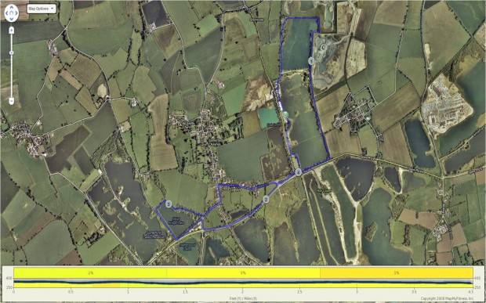
The run course is 3 laps and finishes in a chute adjacent to the race start.

5. Rules and Regulations
The race is a non-drafting event and will be run in accordance with the rules set out by the British Triathlon Federation
Littering will not be tolerated in any shape of form, and any competitor caught littering will be instantly disqualified – No exceptions.
We will aim to provide as many bins as possible on the course and all marshals will have a bin bag, so please hold your gel wrapper etc and discard appropriately.
The courses for this event are through a beautiful part of the country and one complaint for a resident could see the permit for this event cancelled for future years. Please don’t spoil it for the rest of us. Sorry, rant over !

6. Spectators information and Guidelines
This is a ‘Behind Closed doors’ event, so no spectators are allowed within the lake complex around the start and finish area.
100% of the Bike course, and around 50% of the run course are outside of the lake complex.
The best spots to spectate on the bike are on the Spine road Roundabouts by the Devere Cotswold Hotel (cyclists pass here 3 times on the course), and on the run course, from Neighbridge Country Park. Please ask any spectators you may bring not to gather in Somerford Keynes Village on the run course.

7. Points of Contact
During the day, if for any reason you or your family need to get hold of the organisers, then the following contact numbers should be used ;
07595 591612 Graeme Hardie, Race Director
07879 048417 Nicci Hardie, Registration Manager
07979 410455 Steve Dutton – start/finish/transition

8. Age Groups and prize Allocation

In line with the BTF requirements under Covid19, this Event is non competitive, so has no age group or overall prizes.
Your age group will be shown on the results for info only, and will be published in the BTF’s 5yr categories

9. First Aid and Medical Cover

The medical details provided in competitor entry forms have been provided to our Medical partner company, who are providing first aid cover at the event. This information will not be quickly accessible should there be an accident, so please can all competitors mark any medical condition or medication on the reverse of their race numbers

10. Nutrition and Aid Stations
In line with the BTF requirements under Covid19, you must be self sufficient on the bike.
We will have an emergency aid station in case you either have a bottle leak, or you have a bike that can only carry a single bottle. To use this aid station, you must stop, dismount, rack your bike, walk to the collection area and request what is required. The team will then make up a bottle for you, and you can then walk back to your bike on the racking, and proceed on the race.
This Aid station will also have a toilet in place, and the same racking rule applies. If there are two bikes on the racking, you must wait until one has gone, and than rack your bike
On the run course, we will have two Aid stations per lap providing Cupped Water and High5 Iso gels. You must pick what you would like from the table, and not touch the table or anything else you are not taking with you.
The run aid stations will operate a two chute system, where you are directed into one chute, whilst the Aid team Clean and restock the 2nd Chute. Once one chute starts to run low, they will direct you into the other chute, and they will then swap sides, and clean and restock the now empty side.
Both Aid stations will have hand gel at the entrance, and you are requested to use the gel before entering the aid station area if you are planning on collecting anything

11. Post race Massage and recovery area

Due to Covid restrictions, I’m afraid we cannot provide a post race massage or recovery area

12. Race Photography
Race photography will be provided by Charles Whitton Photography. They will have race photographs and finish line pictures available very quickly after the race.
http://www.charleswhittonphotography.com

13. Marshal Support & Day instructions
The Marshals make this event what it is, and without them it just wouldn’t be able to happen.
So with this in mind, please can I ask that all competitors (if safe to do so) try and say thanks to at least one marshal on the way round the course to show them they’re appreciated? It can be a thankless job at times for them stood on a junction guiding you super fast guys and girls on your way to a new PB, so this could be your way of giving something back and showing your appreciation.

14. Relay team Specific Instructions
Relay team members must line up in their area of transition awaiting the team member from the previous section. The baton will be the timing chip. The swim member of the relay team need not wear a number and the cyclist can wear this waiting for the swimmer to pass the timing chip as he enters transition
In line with Social Distancing measures, the timing chip must be wrapped to the transition rack from one side, that person step back, before the next person takes the timing chip from the rack on the other side and then continue on with their race.
If team members are from the same household, they can cross the line together. If not, then a 2m distance must be maintained in the finish chute. The team time will be recorded by the person wearing the timing chip, and the delay for member 2 and 3 is not recorded

15. Covid19 Specific Rules

This is new to us as it is to you, so please accept that we are being very strict on the following as the Safety of you guys, our teams and the local residents is the highest priority here.
We have had to make a number of changes to the way the event is run, and these will have a significant impact on what you’ve been used to if you’ve raced with us before :
- We can allow no spectators on site without exception, and the site will allow competitors, team and Marshals only
- We cannot handle cash transactions with change, so please have £5 cash for Parking and £5 cash for BTF day license if you are not a 2020 member with a card (or photo of your card). Both parking and BTF license payment will be ‘No touch’ so you will drop your money into a bag or tin, so we cannot provide change
- All competitors will be temperature checked by our medical team prior to entering transition and registration. Anyone showing a temperature above the guideline maximum will be turned away
- You must wear a mask in Transition when you first arrive for racking your bike (You do not need to wear a mask once the race has started)
- Transition 1 & 2 (Swim to bike and Bike to Run) times have been neutralized and will not be recorded up to a maximum of 10 minutes for T1 and 5 minutes for T2. This will allow you to social distance during this normally hectic stage of the race
- All race toilets will have Alcohol Hand Gel, and High Alcohol wipes, and you must use these to maintain very high hygiene standards
- Run Aid stations will also have hand gel available, as will all marshals and transition areas, so please use it regularly
- You must keep 2m apart on both the Swim and the Run, and must always keep a 2m width when overtaking on the bike, and abide by the BTF drafting rules of 12m during the whole bike course
- You will need to be self sufficient in terms of Aid on the bike
- If you are unfortunate enough to get a puncture, you will need to carry a spare tube on the bike and be capable of changing this yourself. We will have Moto support guys on the bike, but they can only pass you what is required, and must stand back >2m at all times.
- If you require picking up on the bike course due to terminal mechanical, you must load your own bike into the back of the van, and the pick up team will provide you with a mask and gloves to wear in the van during your recovery back to the lake
- It goes without saying that you absolutely must not attend if you are, or have been, displaying any of the Covid19 Symptoms over the last 14 days, or have been in contact with anyone showing these symptoms
A full explanation can be found at https://www.gov.uk/coronavirus

Final Note
This is the UK, and although it’s Sept and supposedly still just about summer, it can still be cold, windy and wet, so with this in mind, please bring clothing for the bike and run that will stop you from freezing just in case. You can always leave them in transition if you don’t need them.
Typically, in this area we get very little rainfall and a normal Sept Day would be around 15-18deg, but you never know.

Please let me remind you quickly of a couple of main points from above ;

  - On Sunday, you’ll need to register at Transition and have photographic ID with you (BTF license is fine) – If you don’t have your 2020 licence or are not a member, then you’ll need to buy a day license from us for £5 cash and provide alternative photo ID (Passport, driving license etc) – No ID or license, then no registration – No exceptions.
  - Absolutely no littering – Any littering will be instant disqualification.
  - Parking on Sunday will cost £5 cash payable on the gate, so please bring change in hand ready so as not to delay the parking process

Anyway, I hope I haven’t put you all to sleep, so happy racing and if anyone has any questions or wants more information in the meantime, please feel free to get in contact with us on 07595 591612 or Graeme@113events.com

Cheers and Happy racing

Graeme, Nicci and the 113 Events Team

