Cotswold Classic 2018 – Race Information Sheet
Race date – 5th August 2018

Dear Competitor

Please find as follows the full race information pack for competitors of the Cotswold Classic Middle Distance Triathlon on August 5th 2018

Within this race pack we will cover the following;
1. Location & Parking access
2. Registration schedule & details/requirements
3. Race day schedule Inc. Start times and waves
4. Race information
5. Rules and regulations
6. Spectators information and guidelines
7. Points of contact
8. Age groups and prize allocation
9. First Aid & Emergency cover
10. Nutrition and Aid Stations
11. Post race Massage and Recovery Area
12. Race Photography
13. Marshal Support
14. Relay team specific rules

- Location and Parking access
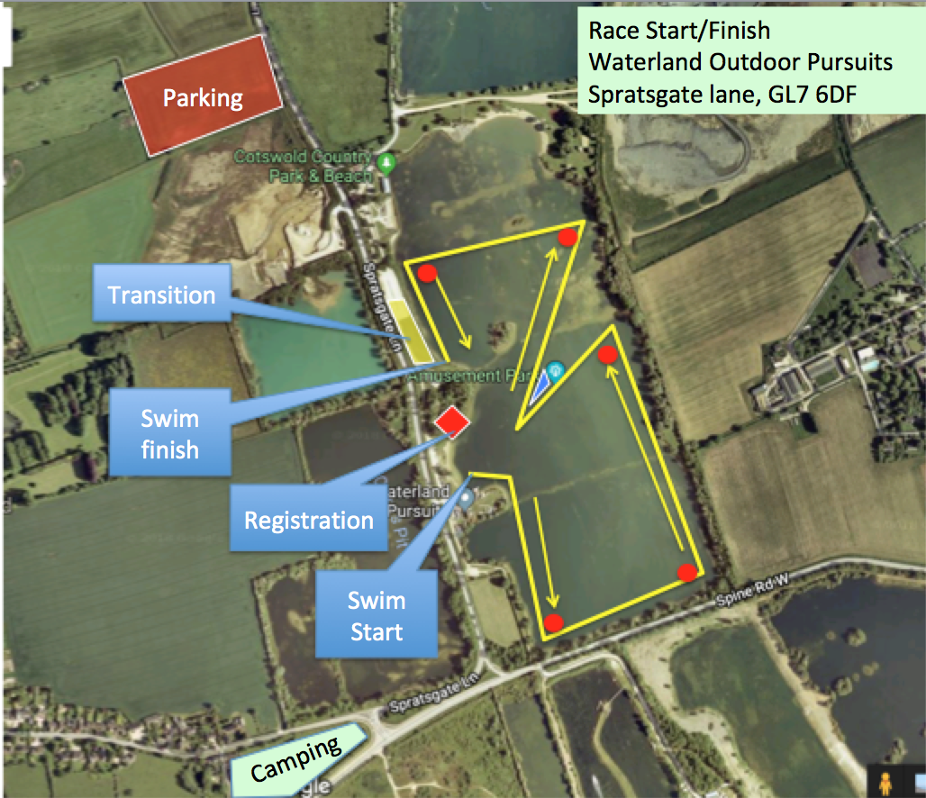

The race will start and finish at Waterland Outdoor pursuits based on Spratsgate lane, Ashton Keynes, Gloucestershire. The postal code for this location is GL7 6DF and it’s located just off the spine road from the A417/9

Parking access on both Saturday and Sunday will be at the above marked Parking Field, which is accessible from both directions on Spratsgate Lane
The area will be open on race morning from 04:00 & 11:30 on Saturday for registration.
Parking is controlled by a local farmer, who donates the profits to a local charity (Last year was Wiltshire Air Ambulance), and carries a charge of £2 for Saturday and £5 for Sunday. This is payable in cash only, so please try and have the correct change to hand on arrival as fumbling for cash at 4am in the dark is not much fun. On Saturday, you can buy Sunday’s parking ticket too, which saves time
This car park will accommodate all competitors + a small amount of spectators. If you can lift share, then this would help the general flow of the day as it will leave more parking spaces for spectators who arrive later in the day.
If it is a sunny day on the day of the race, the waterpark car parks will be full very early, so please be mindful of this is you have spectators arriving later

For those of you camping, then the Go-by-cycle field is located on the end of Spratsgate lane ;

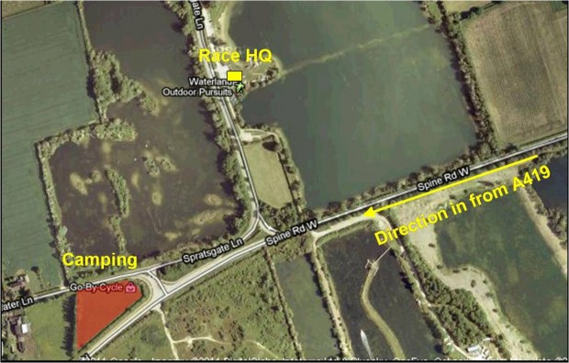

2. Registration schedule & details/requirements
Registration will be open from 12:00 to 17:00 on Saturday the 4th August. If you do need to register earlier than 12:00 due to legitimate commitments, please get in touch and we’ll try to accommodate you individually.
Registration packs will be ready by around lunchtime on Thursday of race week, so if you’re passing Swindon within race week, then you’re welcome to come to our house and collect in advance – We’re 2mins from J16 M4 and our kettle is always on

At registration, you will receive your Race Number, timing chip/strap, goodie bag and Tshirt
Chip Info – Please note that race numbers 501+ may not have chip numbers that correspond with their race numbers – The chip company will provide chip numbers B/C001-B/C*** for these race numbers. We can explain in registration if you’re not sure, but don’t worry if your chip doesn’t exactly match your race number
When registering, please ensure you bring your up to date 2018 BTF Photographic Licence – If you are not a current BTF member or do not have your BTF license with you, then you will need to buy a day licence from us for £5 Cash (unfortunately, we cannot take credit cards or cheques) and provide some photographic ID (i.e. passport or driving licence), so that we can validate that you are who you are. Without this, you will not be able to register – no exceptions.

You will be able to get a friend to register for you, but they will need a note from you saying it’s ok for them to sign on your behalf, a photocopy of your photo ID (BTF license, driving license, passport) and if you’re not a BTF member, then £5 cash for your day licence

3. Race day schedule & Start time

04:00 Car Park opens
04:30 Transition opens for bike racking
06:25 transition Closes
06:20 3min Race briefing takes place at start line for wave 1. Other waves will have briefings 10mins before their swim starts 06:30/06:40/06:50/07:00/07:10/07:20/07:30/07:40/Race Starts – Wave 1/2/3/4/5/6/7/8
15:00 Prize Giving Ceremony by finish area
Please ensure when entering transition, that your bike is labeled up with the supplied race number bike sticker and that you are wearing your helmet fastened so that the safety marshals can check it. (Only competitors with a race number will be allowed to enter transition)
There are 20 x portaloos just past the registration tent near to the race start area.
There will be 2 x portaloos in transition, but these will not be open until the race starts, and will be for use during the race if you need to go in transition
The transition will close for all competitors at 06:25 and must be cleared.
At 06:20 there will be a circa 3 minute race briefing that must be attended by all athletes of wave 1 (this includes all members of relay teams also as it will contain important safety information about Swim, bike and run courses) This will take place at the entrance to the water on the other side of the trees to the transition.
At 06:25 Athletes from wave 1 will be able to enter the water, warm up and line up for the start of the race. Please ensure your timing chip is on your left ankle, secured properly and that you are wearing your supplied coloured Swim hat. The wave you are in will be determined by the colour of your hat.
Athletes in wave 2/3/4/5/6/7/8 will be allowed in the water for 5 mins to warm up after the previous wave has started and cleared the beach.
The race will start for each wave on the sounding of a horn/whistle from the shallow water.
The official cut off time for the race is 15:10, which is 7hrs 30mins after race start of wave 8. There are no individual cut off’s for Swim and Bike, but after around 5.5hrs of racing, many of the bike marshals and Police Support will be pulled from the bike course to support the run area. If you wish to continue on the bike section, you may do so at your own risk and will continue to receive an official bike split right up to 7:30 if you so wish
When collecting your bike from transition, please provide the marshal with your race number so that they can match it to your bike label. Without this, you will not be allowed to remove a bike from transition

4. Race Information

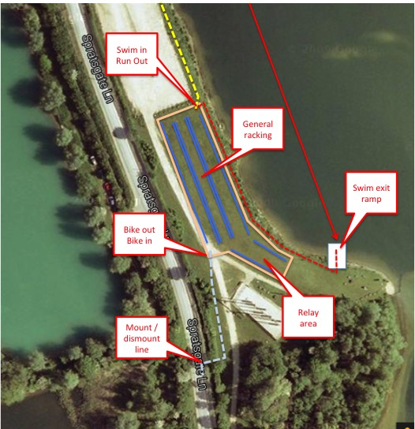

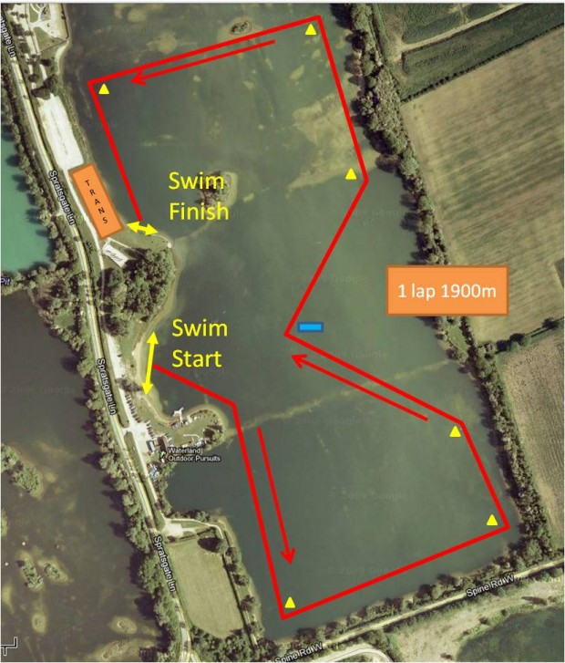
The 1900mtr swim will be one marked anticlockwise lap of the course marked out on the day. You will start in Shallow water in a line marked out between two buoys. The course will marked by using yellow buoys.
Once exiting the water on the ramp marked out by flags, swimmers will make their way into transition through the marked route into the far right hand corner of transition.
In accordance with the BTF regulations, competitors must not remove their bikes from the racking until they have fastened their helmet
Bikes must not be mounted until you reach the mount point approx 30mtrs from transition exit – The surface is suitable for running in both bike shoes and barefooted should you so wish.
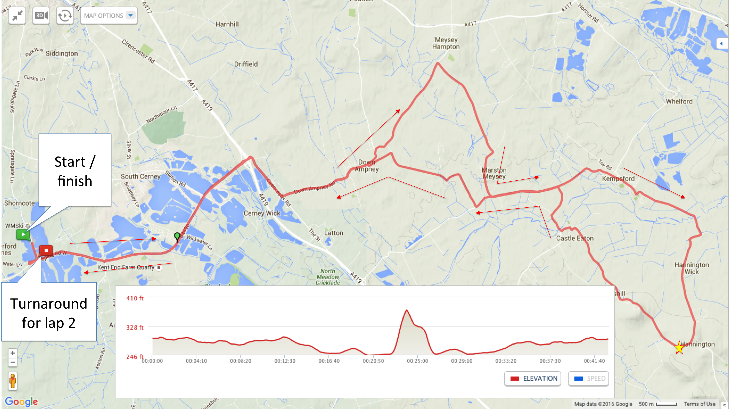
The bike route is two loops, which are predominantly ‘out and back’ with a small hoop on the end and a slight detour in the middle
There will be an aid station located on the Latton road section of the return leg of the lap. You will only be allowed to access the aid station on the return leg (around 24miles and 51 miles) and cyclists must not attempt to use the aid station on the outbound leg of the course as crossing the road at this point is both dangerous to yourself and also to cyclists moving at high speed in the other direction
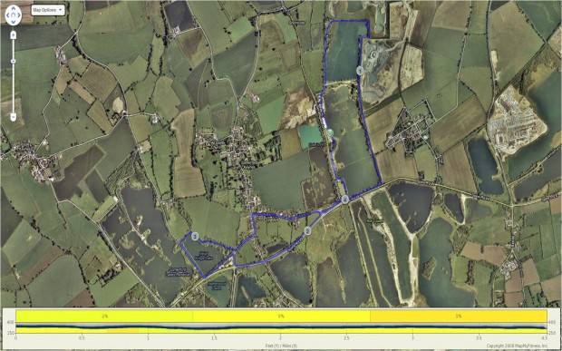
The run course is 3 laps and finishes in a chute adjacent to the race start.

5. Rules and Regulations
The race is a non-drafting event and will be run in accordance with the rules set out by the British Triathlon Federation
Littering will not be tolerated in any shape of form, and any competitor caught littering will be instantly disqualified – No exceptions.
We will aim to provide as many bins as possible on the course and all marshals will have a bin bag, so please hold your gel wrapper etc and discard appropriately.
The courses for this event are through a beautiful part of the country and one complaint for a resident could see the permit for this event cancelled for future years. Please don’t spoil it for the rest of us. Sorry, rant over !

6. Spectators information and Guidelines
The entire site around the lake is free for public access on this day, so spectators can view the race from any location on the race site.
On the run course, approx. 200m after transition, is the Waterpark facility play area, adjacent to their café and also baby change / toilet facilities. This is a good run spectator spot along with many other picturesque parts of the lake and local village
If spectators wish to go and support on the bike, please see our suggested viewing points map.
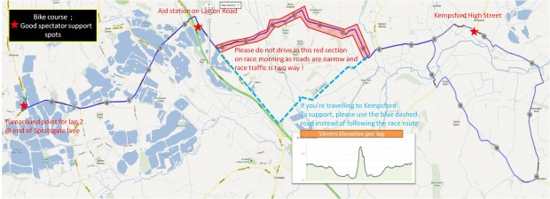
It is important that spectators do not try and follow the flow of the race by car through Down Ampney as the short section of road leading out the other size of the village is exceptionally narrow in parts and not generally used by cars. On race day it will have 1000 competitors on this road and an unnecessary car would cause problems with the flow.
If you wish to view from Kempsford, then please follow the alternative route highlighted on the spectators map.
I would like to politely request that any spectators try to avoid Neils Hill in Hannington. Neils hill is a residential area and the folks that live there do not want to be woken up at 7:30am with screaming race fans outside their windows.
If you are going to support anywhere on the course, then please try to respect the privacy of the residents and ensure that you park your car well away from the road as it’s already narrow in some spots.
If supporters are looking for other activities during the day, then the area where the race is started has a variety of watersports available during the day (http://www.ukwatersports.co.uk) and the area of the lake where transition is held has a man made beach, crazy golf and a cafe/shop (http://cotswoldcountrypark.co.uk)
The is also a head for heights climbing centre based literally over the Swim exit and transition (http://www.head4heights.net/activities.html)

7. Points of Contact
During the day, if for any reason you or your family need to get hold of the organisers, then the following contact numbers should be used ;
07595 591612 Graeme Hardie, Race Director
07879 048417 Nicci Hardie, Registration Manager
07979410455 Steve Dutton – start/finish/transition

8. Age Groups and prize Allocation

We will be publishing results in 5 year age group slots and there will be prizes for presentation available in the following categories
• Male Senior (18-49yrs on race day) 1/2/3
• Female Senior ((18-49yrs) 1/2/3
• Male Vet (50yrs and above) 1/2/3
• Female Vet (50yrs and above ) 1/2/3
- Relay 1st place
Results will be available almost immediately through our timing partners – www.dbmax.co.uk
If you family and friends want to track you live during the day, then we will post a link up to DBmax’s online tracker on the race website over race weekend under the results section http://113events.com/cotswold-classic/results/

Prize giving will take place at 15:00 near to the finish area

9. First Aid and Medical Cover

The medical details provided in competitor entry forms have been provided to our Medical partner company, who are providing first aid cover at the event. This information will not be quickly accessible should there be an accident, so please can all competitors mark any medical condition or medication on the reverse of their race numbers

10. Nutrition and Aid Stations

On the bike course, there will be one aid station located in the layby on the Latton Road
This aid station on the bike course will hold 500 & 750ml Bike bottles containing High5 Carbo drink and Water
There will also be High5 Gels & Bananas
Located just before the aid station will be a bottle drop area. Please ensure that you discard of any unwanted bottles here.
Discarded bottles will be collected up and placed in a pile near to the race HQ after the race, so if anyone wants to collect any bottles that are special to them, this is your opportunity. After this, they will be binned assuming the wasps and ants haven’t already eaten them
The 3 lap run course will have two aid stations. The first will be approximately 2/3 of the way around the lap and will hold the following
• Cupped High5 Carbo drink / water / Flat Coke
• Cut Sections of banana
• Sweets – Jelly beans and babies
• A selection of biscuits, Cake and Salty snacks (ie Very salty Peanuts and Salt & Vinegar crisps)
The second aid station will be located just after the runners pass by transition and will hold only cupped water and gels.
If the weather is exceptionally hot as per 2011, then we will endeavor to provide another water station on the course

11. Post race Massage and recovery area

After you cross the finish line there will be an area with eight kind ladies who will be providing post race massage for your tired legs. These ladies are fully qualified and are provided Free of Charge to competitors. Please try not to scream too loudly as it upsets both the swans and ducks in the lake, and you honestly don’t want to try outrunning either on tired legs.

12. Race Photography
Free Race photography will be provided by Charles Whitton Photography. They will have race photographs and finish line pictures available very quickly after the race. We will pay for one free downloadable photo from your collection, and they will have many others for sale should you want more or to have them printed onto a mug or other types of memorabilia
http://www.charleswhittonphotography.com

13. Marshal Support & Day instructions
The Marshals make this event what it is, and without them it just wouldn’t be able to happen.
So with this in mind, please can I ask that all competitors (if safe to do so) try and say thanks to at least one marshal on the way round the course to show them they’re appreciated? It can be a thankless job at times for them stood on a junction guiding you super fast guys and girls on your way to a new PB, so this could be your way of giving something back and showing your appreciation.
Also, we’re always after more marshals, so if your wives, husbands, sisters, brothers, friends, colleagues, enemies etc are coming with you on the day and want to earn a special 113 team tech shirt, a £40 113 events 2018/2019 voucher or £20 cash and a free cup of tea, burger and an ice cream as well as a great view of the race and to be part of the event, then please email me at Graeme@113events.com
No experience is required, just the ability to shout support and to know your left from right.

14. Relay team Specific Instructions
Relay team members must line up in their area of transition awaiting the team member from the previous section. The baton will be the timing chip. The swim member of the relay team need not wear a number and the cyclist can wear this waiting for the swimmer to pass the timing chip as he enters transition
All relay members must attend the safety briefing next to the water as this contains important information about the day.

Final Note
This is the UK, and although it’s June and supposedly summer, it can still be cold, windy and wet, so with this in mind, please bring clothing for the bike and run that will stop you from freezing just in case. You can always leave them in transition if you don’t need them.
Typically, in this area we get very little rainfall and a normal June Day would be around 18-20deg, but you never know.

Please let me remind you quickly of a couple of main points from above ;

  - On Saturday, you’ll need to register and have photographic ID with you (BTF license is fine) – If you don’t have your 2018 licence or are not a member, then you’ll need to buy a day license from us for £5 cash and provide alternative photo ID (Passport, driving license etc) – No ID or license, then no registration – No exceptions, sorry.
  - All competitors must attend the safety briefing near to the swim start 10 mins prior to your race start time on Sunday morning
  - Absolutely no littering – Any littering will be instant disqualification if spotted
  - Parking on Saturday is £2 and Sunday will cost £5 cash payable on the gate, so please bring change in hand ready so as not to delay the parking process

Anyway, I hope I haven’t put you all to sleep, so happy racing and if anyone has any questions or wants more information in the meantime, please feel free to get in contact with us on 07595 591612 or Graeme@113events.com

Cheers and Happy racing

Graeme, Nicci and the 113 Events Team

